

Functional Requirements Document (FRD)

In
finity Sports
, Inc.
–

J898108

Copyright© 2018, Oracle and/or its affiliates. All rights reserved.
Any reproduction or distribution of any part of this document without the prior written permission of Oracle + NetSuite is strictly prohibited.
The information included in this document is confidential and proprietary information of Oracle + NetSuite. Version: March 3, 2022

Oracle + NetSuite
2955 Campus Drive, Suite 100
San Mateo, CA. 99403-2511

Project Information
Implementation Name | SS4C Customization
Customer Name (Number) | Infinity Sports, Inc.
Job Name (Number) | J898108
Document Owner | Aarti Joshi
Project Manager | Aarti Joshi
Lead Developer | Ilan Daniele

Document Version History
Rev | Date | Author(s) | Change Summary
1.0 | 03/02/2023 | Aarti Joshi | Initial Draft

Table of Contents
- Business needs ............................................................................................................................... 3
- Impacted areas/modules [Optional as output] ............................................................................... 3
- Acceptance criteria......................................................................................................................... 3
- Solution proposal ........................................................................................................................... 3
- Prerequisites .................................................................................................................................. 4
- Assumptions .................................................................................................................................. 4
- Constraints and limitations ............................................................................................................ 4
- Risks .............................................................................................................................................. 4

1 Business needs
Gun Accessory Supply is a wholesale distributor providing firearm accessories and sport optics through freight programs and financing options. There current client is using CSV import to add multiple items at once into the cart. They want to keep this feature the same so that they can utilize it continuously.

Feature 1: Upload Items to Cart feature:
- Create up to one (1) script to allow the upload of a Comma Separated Value (“CSV”) file.
- Create up to one (1) script to add line items and their quantities to the shopping cart page from an uploaded CSV file.

2 Impacted areas/modules [Optional as output]
Quick Order

3 Acceptance criteria
- CSV import option/button should be displayed in Quick Order page only after customer logged in.
- Customer should be able to download the CSV template.
- Customer should be able to upload the CSV file.
- Once CSV file is imported, items from CSV file should get added to the cart.
- All the items with quantity should be displayed in cart.

4 Solution proposal
Feature: Upload Items to Cart feature
After customer is logged in, on quick order view, the client desires to see an import CSV Order section which contains a “Download template” button and an import file button:
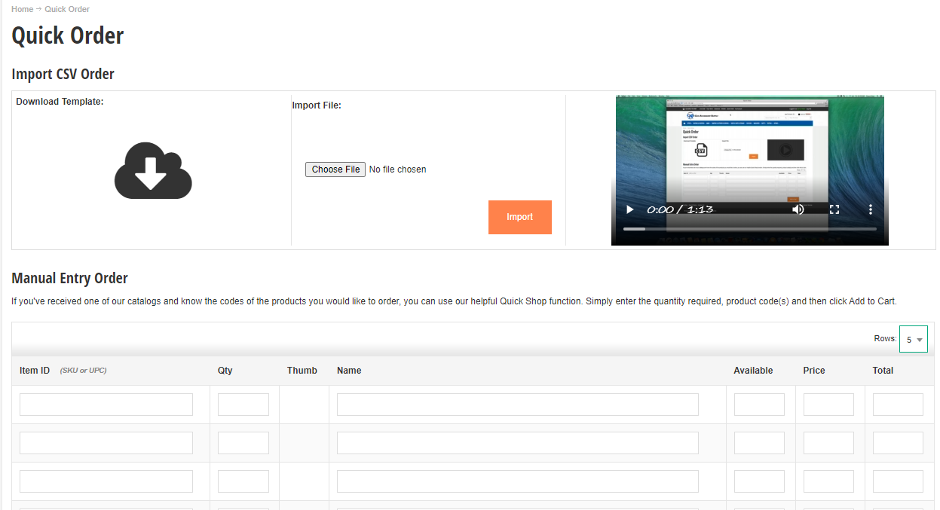
If client press on “download template” it will download the example CSV that the client needs to use to add certain items to cart.
“Import File” button will allow the user to import the CSV created following the template given. Format of CSV will be the following:
SKU Quantity
On SKU client will pass the complete product SKU (with item options). There can be matrix items, but just by passing the complete name with options selected, we can retrieve given the SKU, the internal id of the item and add it to cart.
Once “import file” is pressed, a pop up window will show up to be able to select the appropriate CSV file. Customer will select the appropriate CSV file, and this file will be processed.
Our extension will process each of the lines of the CSV and will start adding to cart each item mapping it’s sku and adding its quantities to cart and item options. This process can take a little while. All the lines from the CSV up to 20 will get added to cart, and a result message will show up after the import:
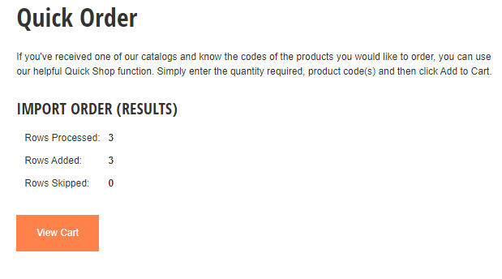
This result section will show how many rows from the CSV were processed, how many were added to cart, and how many were skipped / not added to cart.

5 Prerequisites
- Customer must be logged in to the site.
6 Assumption
- Items are just added in cart and details will be displayed as is.
- There will be at most, 20 items on CSV to be added to cart.

7 Constraints and limitations
There is a risk of slow user experience due to the addition to items to cart through CSV
There can be up to 20 items in the cart.

8 Risks
Oracle + NetSuite Professional Services and Customer are in agreement that the information documented above is accurate and representative of the customer’s business needs. This document will act as the basis for all subsequent implementation activities.
Document delivery date: MM/DD/YYYY

